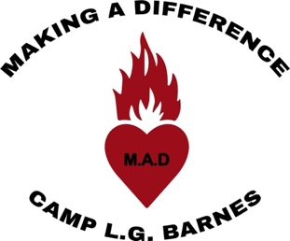

Camp L.G. Barnes Wishlist

Thank you so much for considering helping our camp with both new and ongoing expenses. As a registered charity, we rely on generosity from individuals, families and businesses to operate.

The following items are only a small list of our immediate needs. If you have other items that might benefit our camp, please contact us and we will determine with you how it can be put to use.

The camp needs a smaller car to utilize to travel around the province promoting the camp. Our camp truck runs well, however is not cheap on gas (Ford F250). We have approached a couple of dealerships, but have yet to have success in obtaining a sponsored vehicle.

Cleaning Supplies:
H2E Liquid Laundry Soap
Bleach
Dryer Fabric Sheets
Comet
Lysol Disinfectant Wipes
Toilet Paper
Paper Towels

This list will be updated regularly as more needs are determined. Please consider supporting with a cash donation to purchase items if you are not able to shop and deliver.

We cannot continue without your support! Thank you for your contribution (no matter the size).

Sincerely,

Rev. David Bayduza
Executive Director

